LittleSteps Operational Analytics Report
Introduction
LittleSteps provides home-based healthcare services delivered by nurses across multiple locations. The objective of this analysis was to understand operational performance, visit duration behaviour, travel patterns, service complexity, and the influence of nurse notes on visit outcomes. The analysis was conducted on the processed dataset generated during the data preparation phase.
Data Preparation Summary
The raw dataset underwent cleaning and preprocessing before analysis. Key steps included duplicate removal, datetime standardisation, visit duration calculation, creation of travel-duration proxies, nurse note categorisation, handling of missing values, and validation of operational records. Travel duration was treated as a proxy measure based on the gap between consecutive visits and filtered to exclude unrealistic overnight gaps.
Distribution of Visit Durations
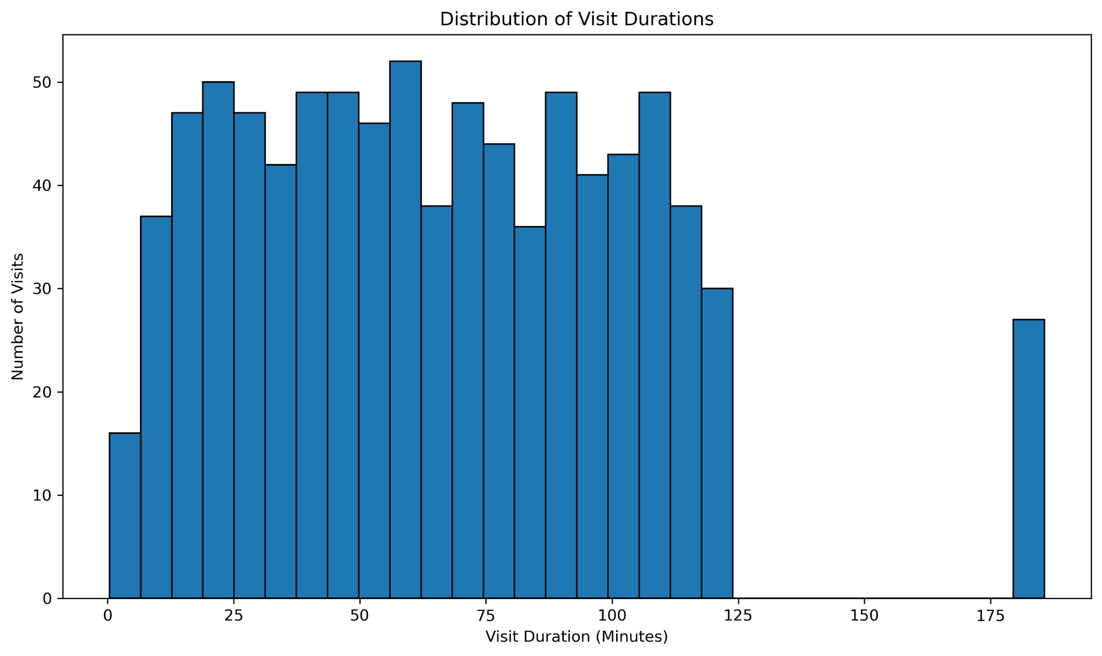
The histogram shows substantial variability in visit durations. Most visits fall within the normal operating range, but a small number of very long visits exceed 180 minutes. These outliers likely represent highly complex cases, extensive treatment procedures, or exceptional operational circumstances. This finding suggests that a fixed appointment duration may not be appropriate for all patient visits and supports the need for dynamic scheduling.
Visit Duration by Service Type
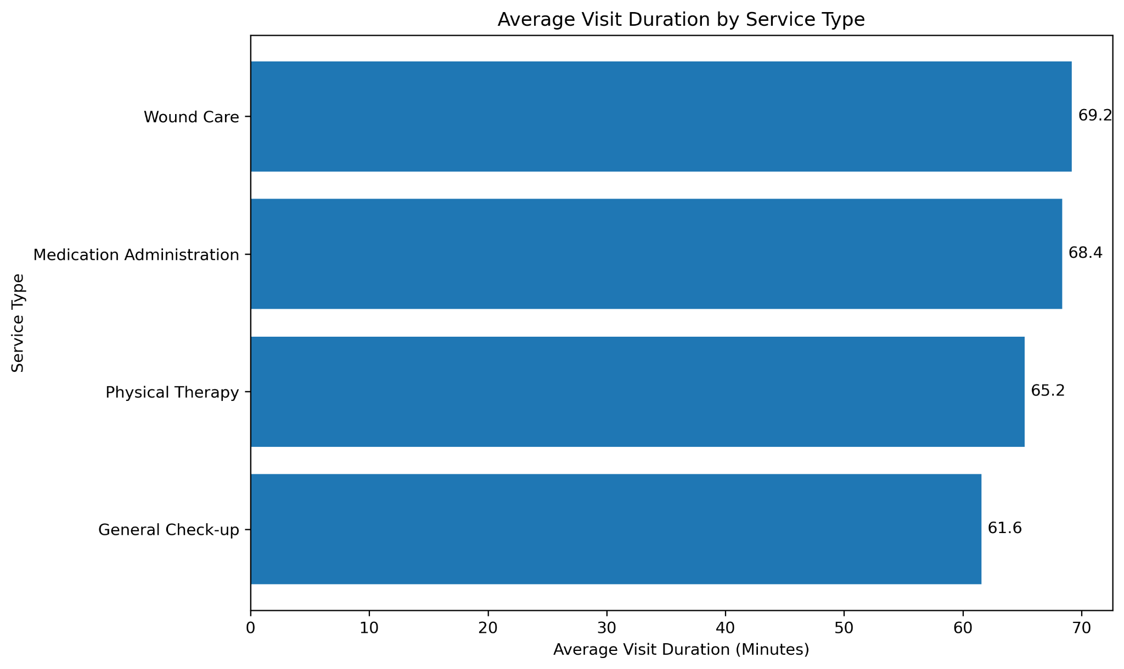
Wound Care recorded the highest average visit duration (69.2 minutes), followed closely by Medication Administration (68.4 minutes). Physical Therapy averaged 65.2 minutes, while General Check-ups averaged only 61.6 minutes. The difference indicates that wound-care activities require more clinical attention, monitoring, documentation, and patient interaction. Service-specific scheduling templates should therefore be adopted rather than allocating equal appointment lengths across all services.

Service Volume Analysis
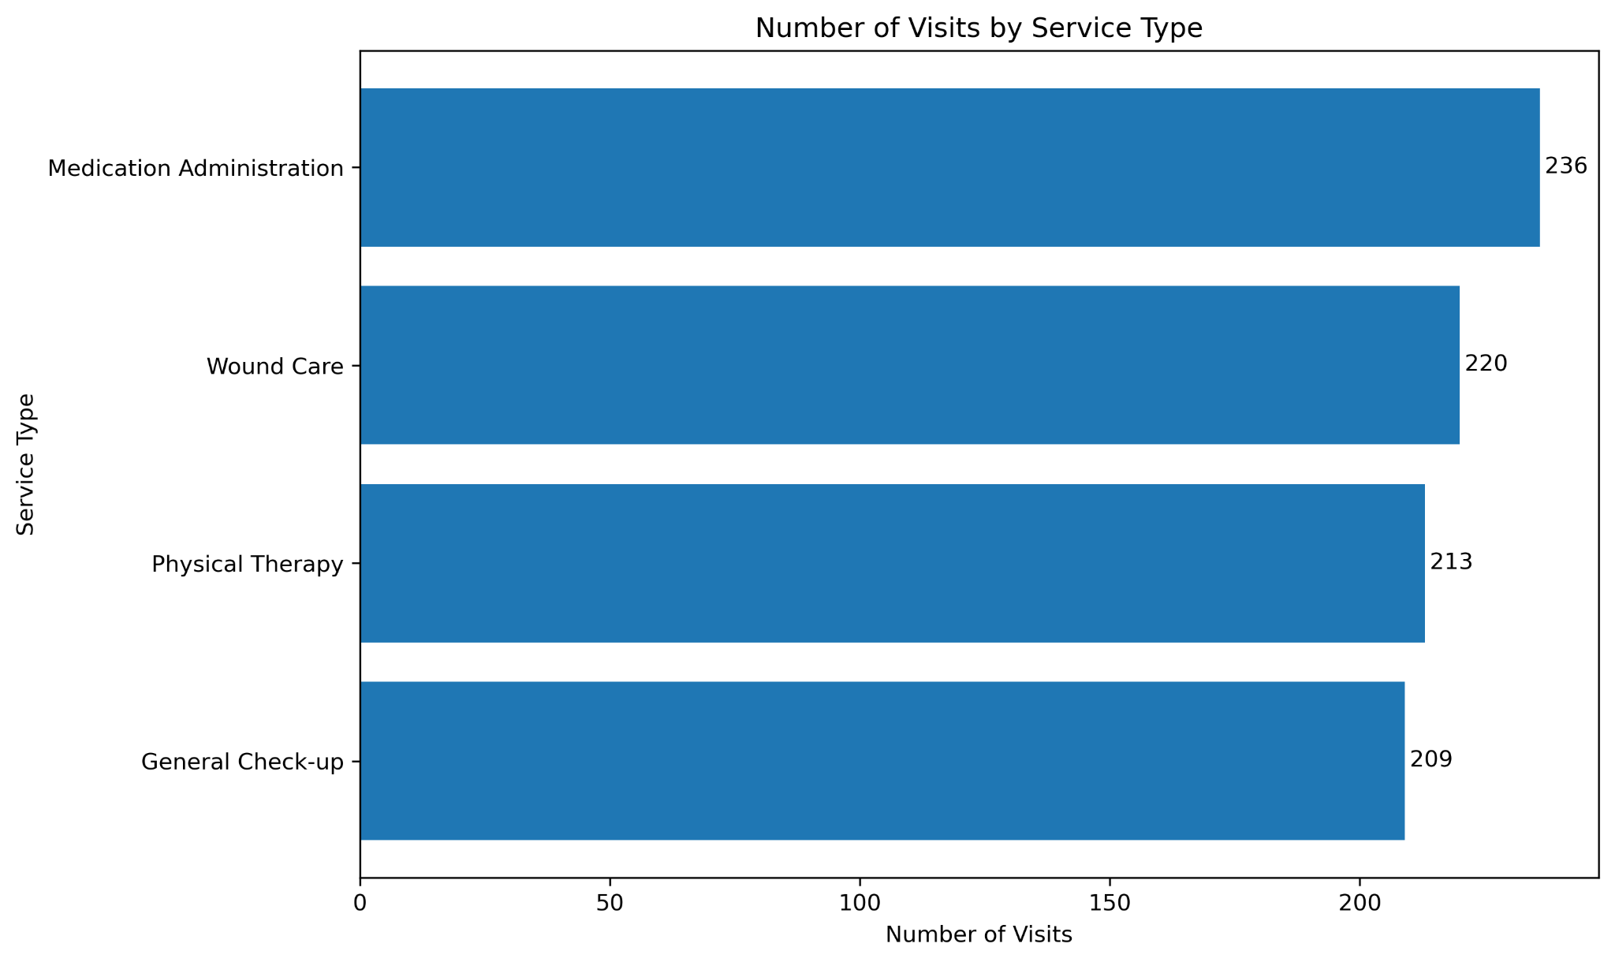
Medication Administration generated the highest workload volume with 236 visits. Although Wound Care requires slightly longer visits, Medication Administration combines both high volume and relatively long duration. Consequently, it consumes a significant proportion of nursing resources and should be prioritised for workforce planning and operational optimisation initiatives.
Travel Duration by Service Type
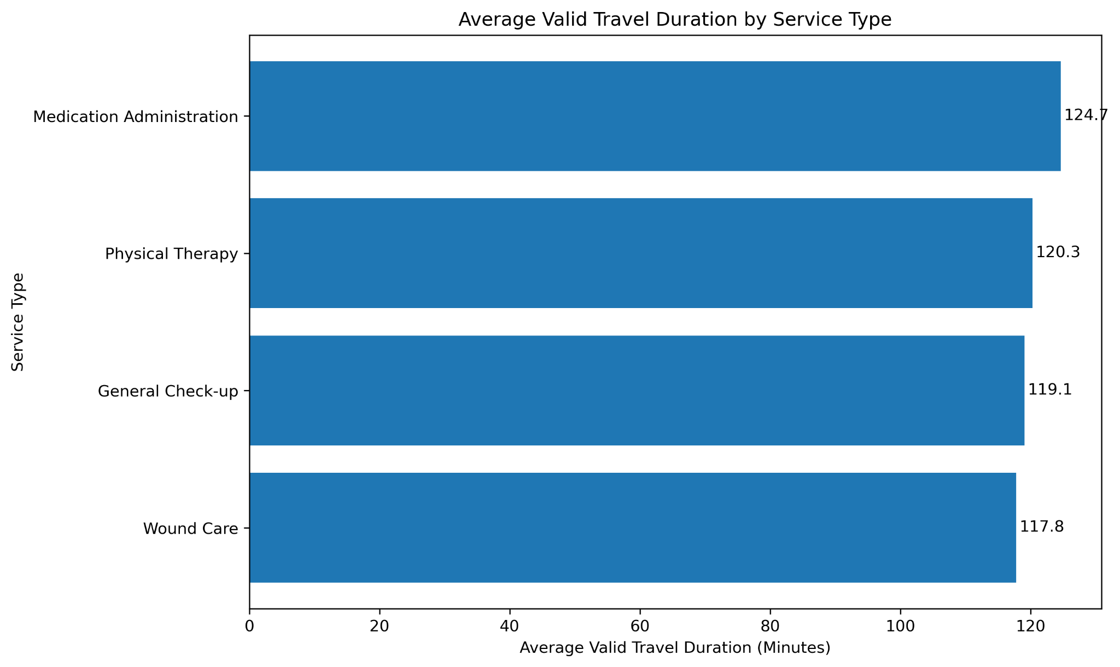
Average travel durations are broadly similar across service types, ranging from approximately 118 to 125 minutes. This suggests that travel time is driven primarily by scheduling practices, route allocation, and geographical distribution rather than by the service being performed. Improvements should therefore focus on route optimisation and territory planning.
Location-Based Analysis
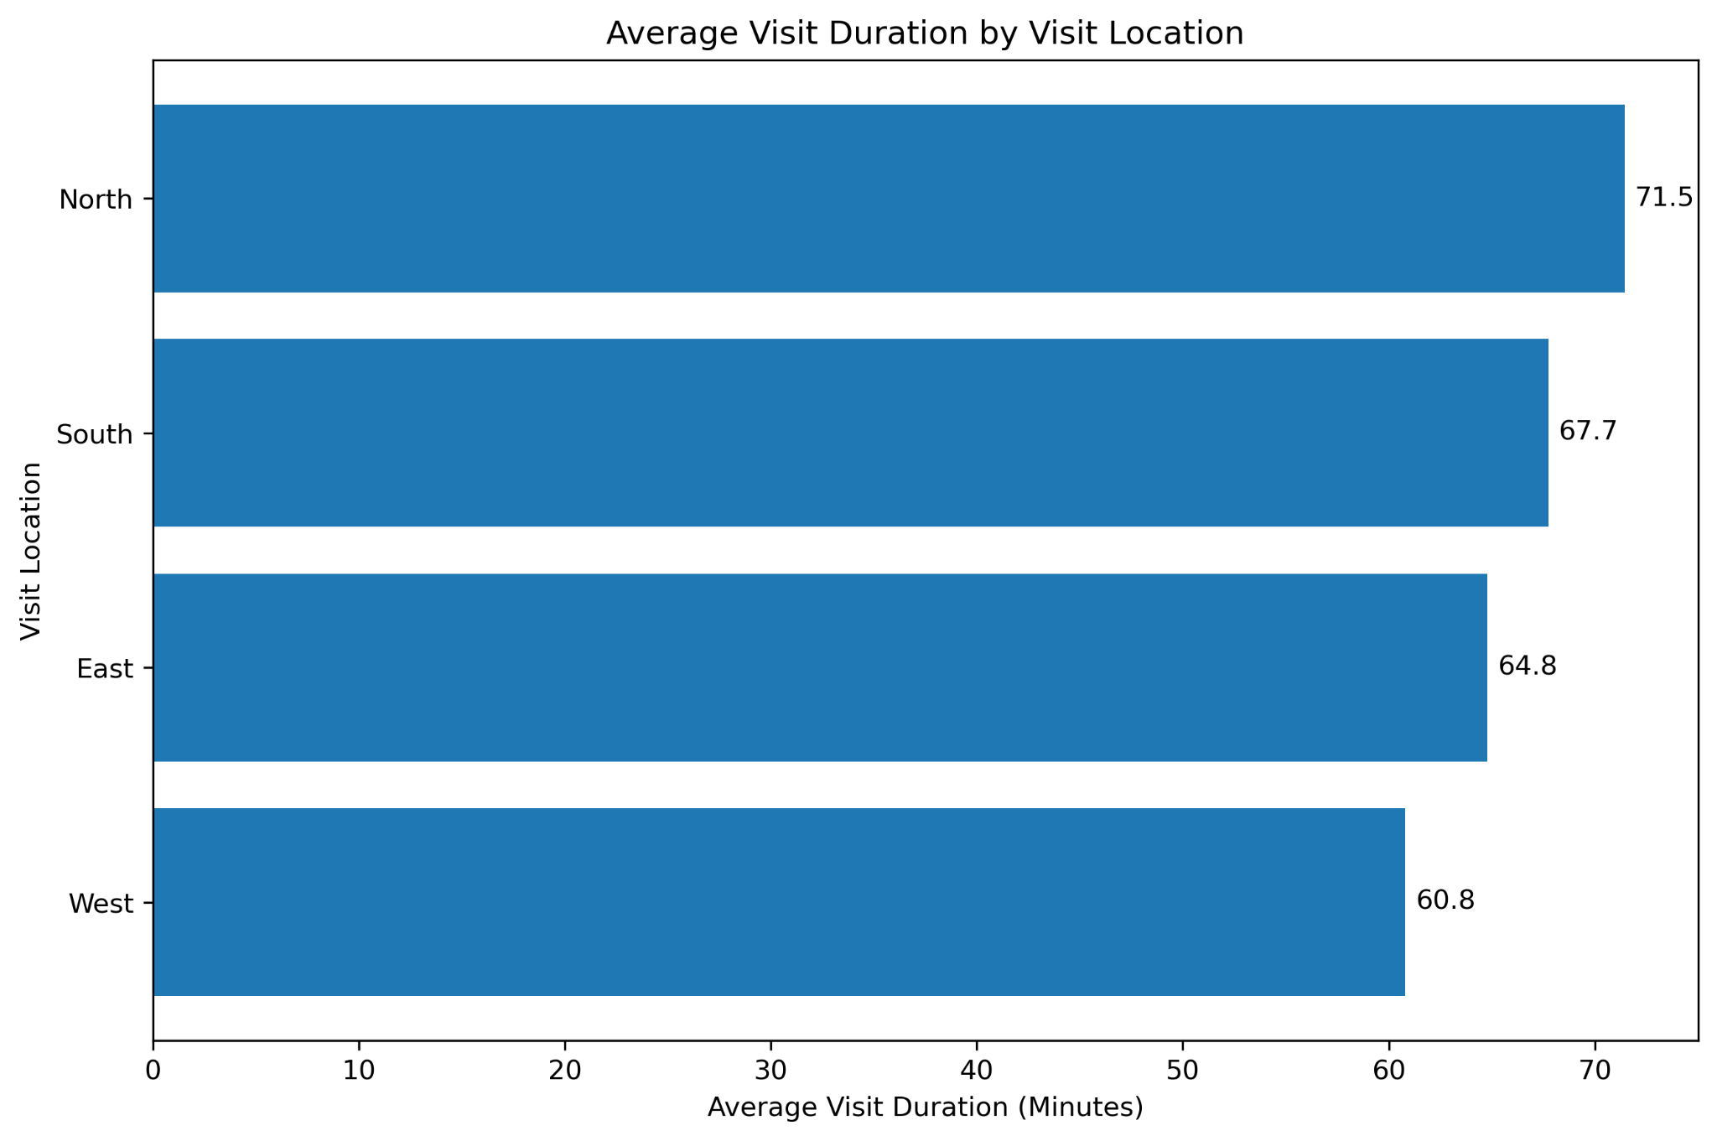
North recorded the highest average visit duration at 71.5 minutes, while West recorded the lowest at 60.8 minutes. This difference of more than 10 minutes per visit represents a substantial operational impact when aggregated across hundreds of visits. Possible causes include differences in patient complexity, demographic characteristics, staffing allocation, or local operating conditions.

Distribution of Visit Duration by Location
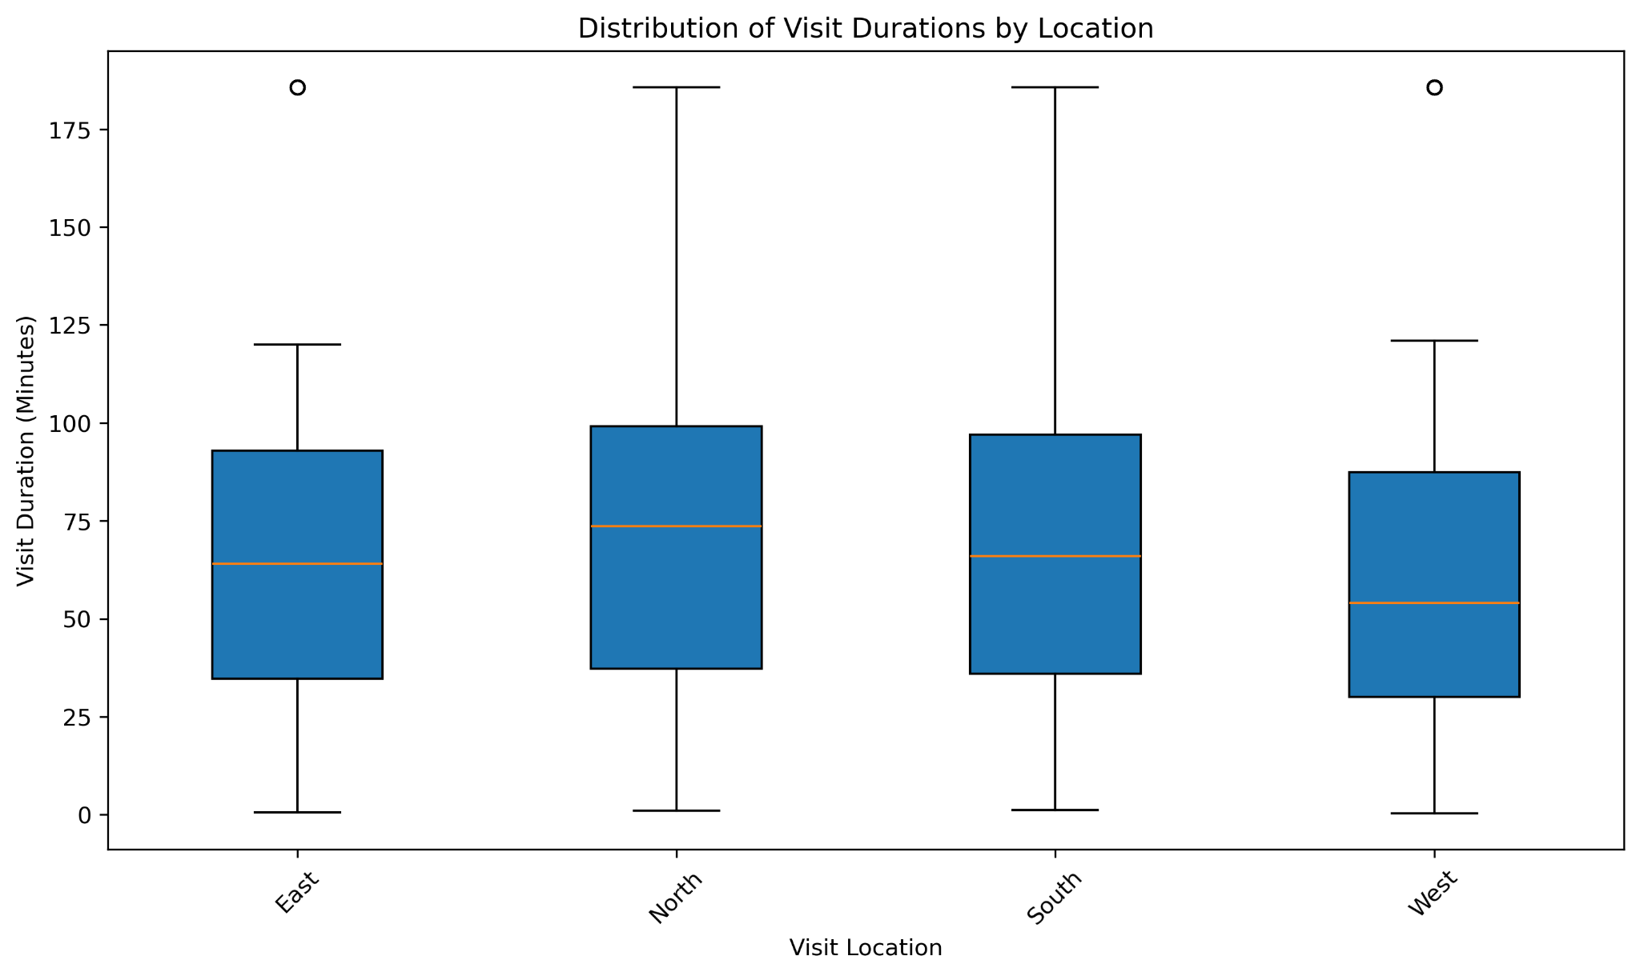
The boxplots demonstrate that all locations contain a mix of short and long visits. North and South show higher median visit durations, while West generally exhibits shorter visit durations. The wide spread within each location indicates that case complexity varies significantly even within the same geographical area.
Service Type and Location Interaction
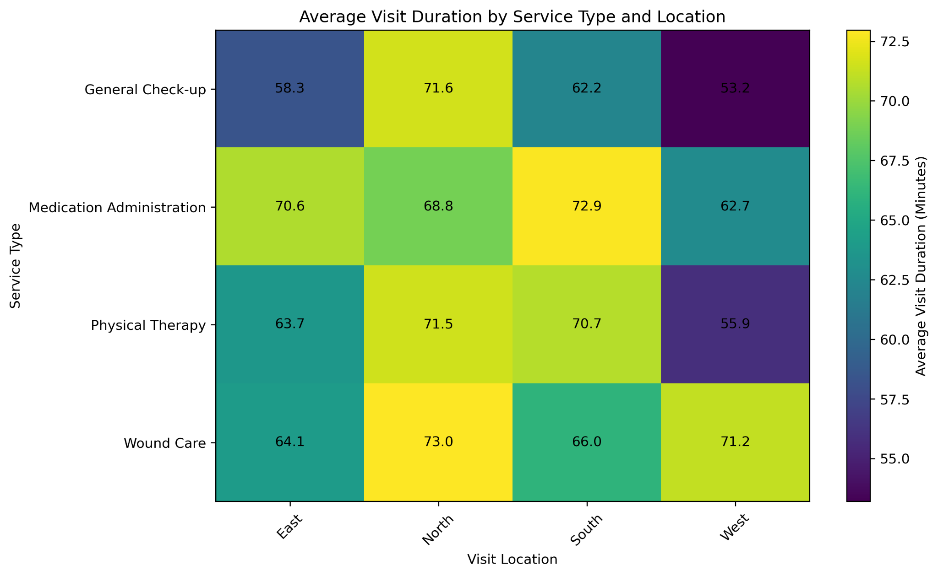
The heatmap reveals that visit duration is influenced simultaneously by service type and location. For example, Wound Care in the North averages approximately 73 minutes while General Check-ups in the West average approximately 53 minutes. The highest-duration combinations require nearly 40% more time than the lowest-duration combinations.
This finding strongly supports adopting scheduling rules that incorporate both service type and location.
Nurse Travel Duration Analysis
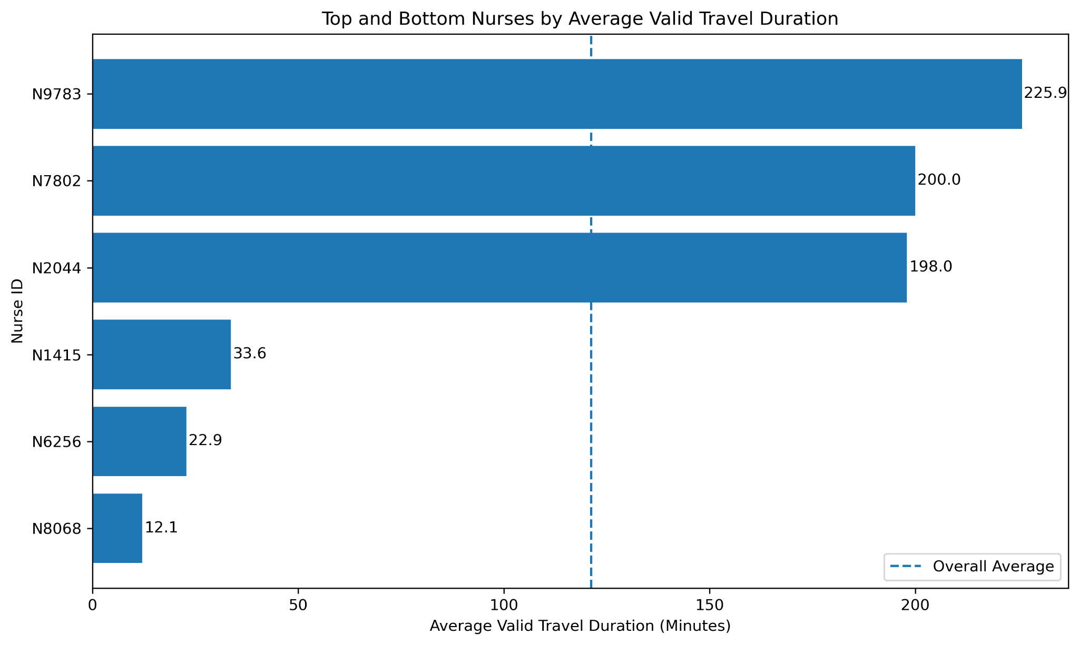
Substantial variation exists between nurses. The highest travel-duration nurses exceed 190 minutes on average, while the lowest are below 35 minutes. Such differences suggest route inefficiencies, uneven territory assignment, or fragmented scheduling. Route optimisation and improved clustering of appointments could significantly reduce non-value-added travel time and increase patient-facing capacity.

Nurse Note Outcome Analysis
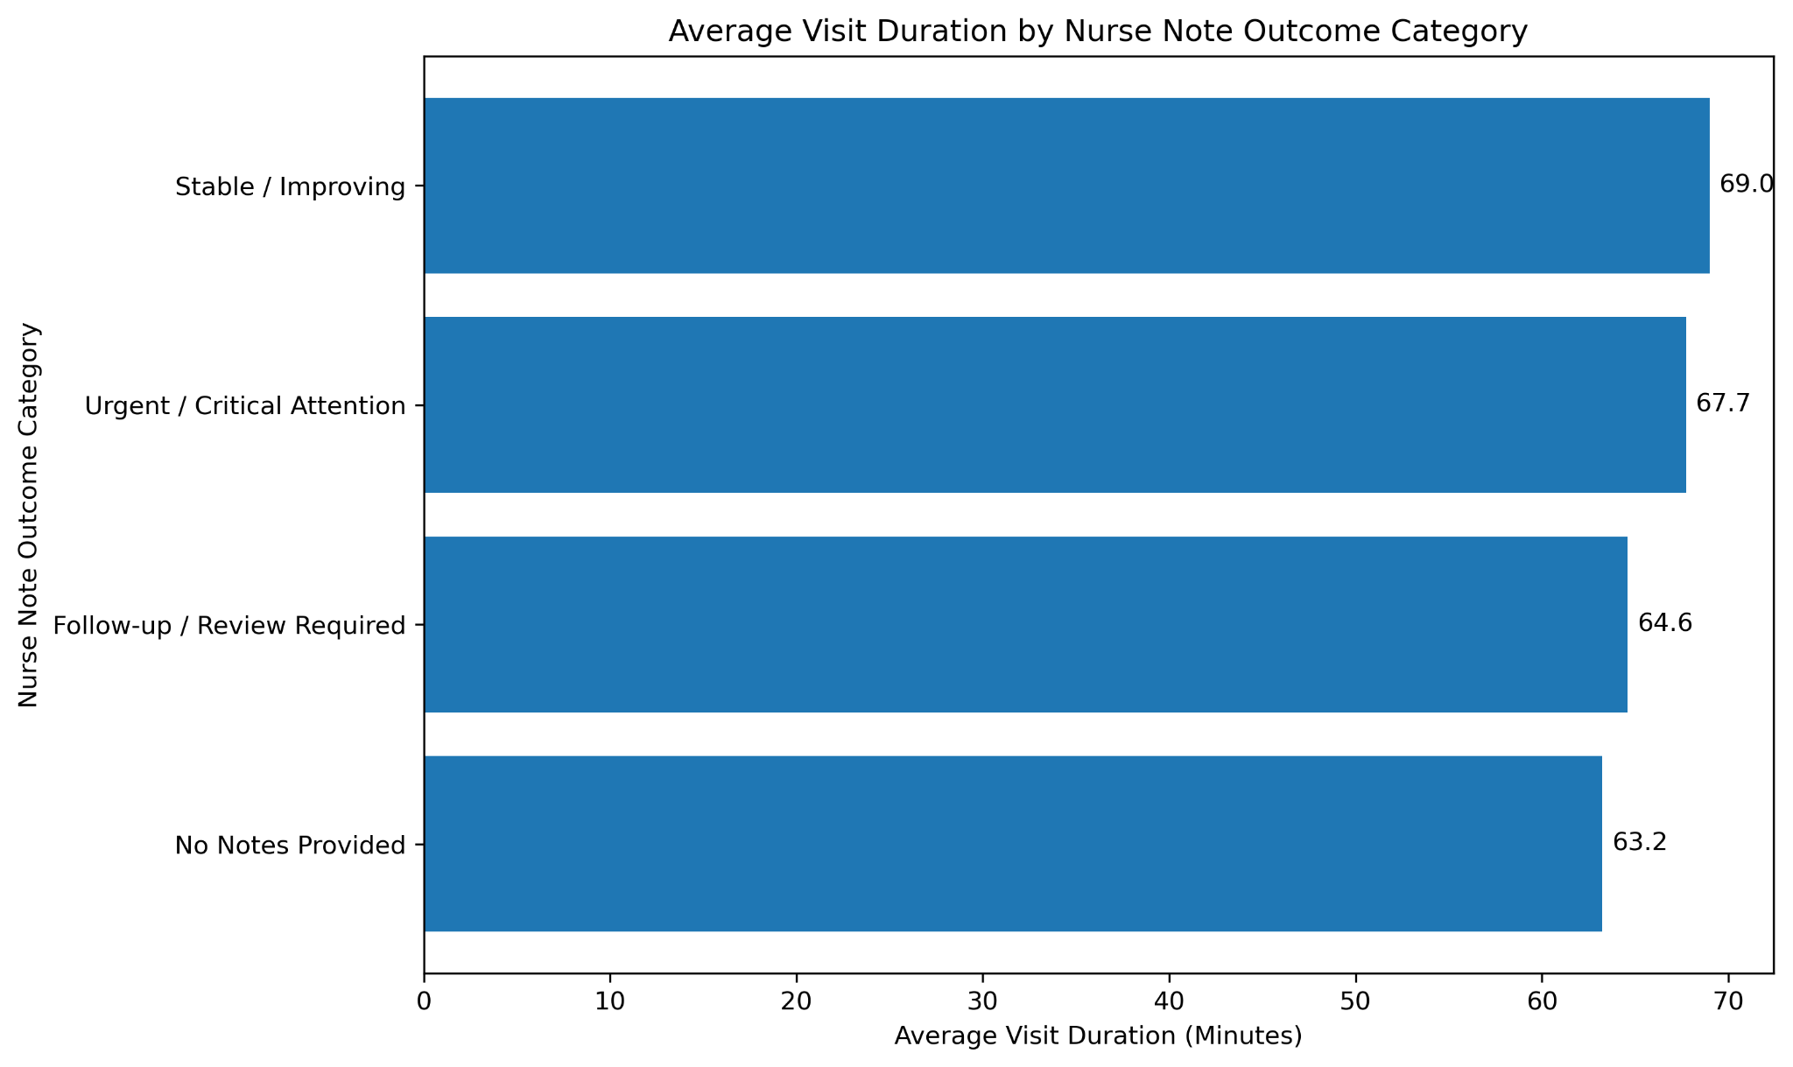
Visits classified as Stable/Improving recorded the longest average durations at approximately 69 minutes. Urgent/Critical Attention visits also required substantial time. Interestingly, visits with no notes tended to be shorter. Nurse notes therefore provide valuable contextual information that may help predict appointment duration.
Keyword Impact Analysis
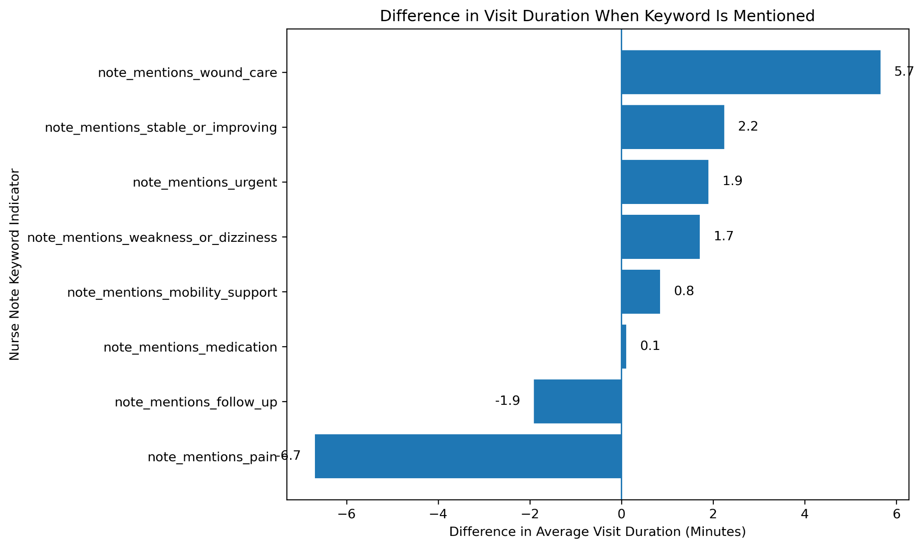
Mentions of wound care increased visit duration by approximately 5.7 minutes on average, making it the strongest duration driver. Keywords related to urgent conditions, weakness, dizziness, and mobility support also increased visit duration. These findings demonstrate that textual nurse notes contain operationally useful information and could be incorporated into future scheduling models to predict expected appointment length.
Key Business Insights
- Wound Care and Medication Administration are the most resource-intensive services.
The analysis revealed that Wound Care (69.2 minutes) and Medication Administration (68.4 minutes) have the highest average visit durations among all service categories. In addition, Medication Administration recorded the highest service volume with 236 visits. This combination of high frequency and long visit duration means that these services consume a disproportionately large share of nursing resources and operational capacity. As a result, any improvements in scheduling, workflow efficiency, or resource allocation within these service categories are likely to generate the greatest operational benefits for LittleSteps.
- Medication Administration represents the largest workload segment and therefore offers the greatest optimisation potential.
Although Wound Care recorded the longest average visit duration, Medication Administration generated the highest number of visits while also maintaining a relatively long average service time. This makes it the largest contributor to overall nurse workload and one of the most critical services from a resource planning perspective. Even small efficiency improvements within this service category could result in significant cumulative time savings and increased nursing capacity, making it a priority area for operational improvement initiatives.
- North consistently exhibits the longest visit durations, suggesting either more complex patients or operational inefficiencies.
The North region recorded the highest average visit duration at approximately 71.5 minutes compared to only 60.8 minutes in the West region. This difference of more than 10 minutes per visit becomes significant when aggregated across hundreds of visits and may indicate higher patient complexity, greater treatment requirements, staffing constraints, or scheduling inefficiencies within the region. Further investigation is required to determine whether these longer durations are clinically necessary or whether operational improvements can be implemented to improve efficiency.
- Nurse travel time varies dramatically between nurses, indicating opportunities for route optimisation.
The travel duration analysis showed substantial variation between nurses, with the highest-travel nurses recording average transition times of approximately 198–226 minutes compared to only 12–34 minutes for the lowest-travel nurses. Although travel duration was estimated using the gap between consecutive visits, the scale of this difference suggests potential inefficiencies in appointment allocation, route planning, or territory assignment. Reducing excessive travel time would allow nurses to spend more time providing direct patient care while improving overall operational productivity.
- Nurse notes contain valuable predictive signals regarding visit complexity and expected duration.
The nurse note analysis demonstrated that certain keywords are associated with longer visit durations. In particular, wound-care related notes increased average visit duration by approximately 5.7 minutes, while urgent conditions, weakness, dizziness, and mobility support requirements were also associated with longer visits. These findings suggest that nurse notes capture important contextual information about patient complexity and could be incorporated into future scheduling processes to improve appointment duration estimates and resource planning.
- Service type alone does not explain duration variation; location and patient context also play important roles.
The service-location heatmap showed that visit duration is influenced by multiple factors simultaneously. For example, Wound Care in the North region required substantially more time than General Check-ups in the West region, with the longest service-location combinations requiring nearly 40% more time than the shortest. This indicates that a standard appointment duration based solely on service type may not accurately reflect operational requirements, highlighting the importance of incorporating location and patient context into scheduling decisions.
Strategic Recommendations
Recommendation 1: Introduce service-specific appointment durations.
The clear differences in average visit duration across service categories indicate that a standard appointment length may not be appropriate for all services. LittleSteps should implement service-specific scheduling templates that allocate longer appointment slots for resource-intensive services such as Wound Care and Medication Administration while maintaining shorter slots for less time-intensive services. This would improve scheduling accuracy, reduce delays, and create a more realistic workload distribution for nurses.
Recommendation 2: Conduct a focused operational review of the North region.
Given that the North region consistently recorded the longest average visit durations, management should conduct a detailed review of patient complexity, staffing levels, travel requirements, and scheduling practices within the region. Understanding the underlying causes of longer visit durations will help determine whether the issue is driven by legitimate clinical needs or whether operational improvements can be implemented to improve efficiency and resource utilisation.
Recommendation 3: Implement route optimisation and territory balancing.
The significant variation in nurse travel durations suggests that appointment allocation and route planning may not be optimally configured. LittleSteps should evaluate geographic clustering of appointments, nurse territories, and daily schedules to reduce unnecessary travel and transition time. More efficient routing could increase patient-facing capacity, reduce operational costs, and improve nurse productivity.
Recommendation 4: Incorporate nurse-note information into scheduling decisions.
Since nurse notes were found to contain useful indicators of visit complexity, LittleSteps should consider integrating note-derived keywords into appointment planning processes. Visits involving wound care, mobility support, urgent care requirements, or other complex patient needs could automatically receive longer appointment allocations, resulting in more accurate schedules and fewer service delays.
Recommendation 5: Improve travel data collection.
A key limitation of the current analysis is that travel duration had to be estimated using the time gap between consecutive visits rather than actual travel information. Future systems should capture GPS locations, route distances, travel times, and nurse check-in/check-out data to enable more accurate measurement of travel efficiency and support advanced route optimisation initiatives.
Recommendation 6: Develop service-location scheduling templates.
The analysis showed that visit duration varies not only by service type but also by location. LittleSteps should therefore consider creating scheduling templates that account for both factors simultaneously. Such an approach would better reflect real-world operational requirements and improve workforce planning accuracy.
Recommendation 7: Monitor duration outliers and emerging bottlenecks.
Several unusually long visits were observed within the dataset, indicating the potential presence of operational bottlenecks or highly complex cases. Establishing a monitoring framework for duration outliers would allow management to identify recurring issues, investigate root causes, and implement corrective actions before inefficiencies begin affecting overall service performance.
Limitations
Travel duration was estimated using the time gap between consecutive visits and does not represent actual travel time. GPS routes, traffic conditions, and transportation data were unavailable. Therefore, travel-related findings should be interpreted as indicators of scheduling efficiency rather than precise travel measurements.

Conclusion
The analysis provides a comprehensive assessment of LittleSteps operational performance. Significant differences were identified across service types, locations, nurses, and patient contexts. The findings indicate clear opportunities to improve scheduling, resource allocation, route planning, and workload management. Implementing the recommendations outlined in this report would likely improve operational efficiency, reduce non-value-added time, and enhance service delivery quality.

